1. First, we find the covariance matrix of the given matrix. For the given matrix, the covariance matrix will be a 2x2 matrix of the form:

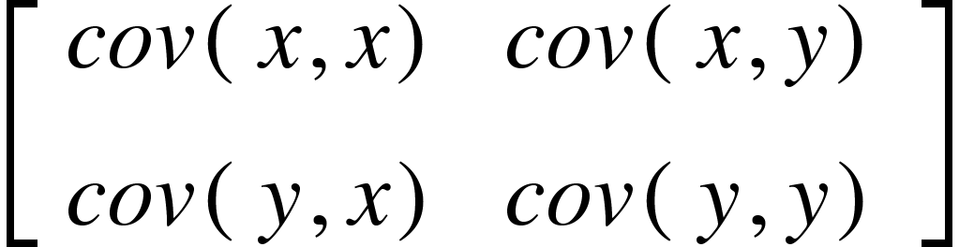

To find the covariances, we need to determine the X with bar on top and Y with bar on top.

* = 
* = 

Now, we can compute the covariance using this formula:

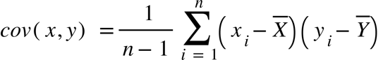

With n being the number of columns.

So, we get this covariance matrix:

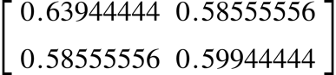

Now, we need to compute the eigenvalues and the eigenvectors for the covariance matrix:

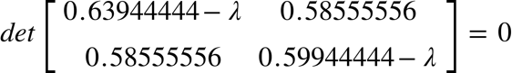

This yields a quadratic equation:  = 0 and solving this equation gives us the eigenvalues 1.20534146 and 0.03354743.

The first PCA corresponding to the eigenvectors resulting from the largest eigenvalue. For the first PCA is 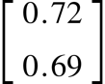 and the second PCA corresponding to the second largest eigenvalue is 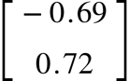.

2. 1. 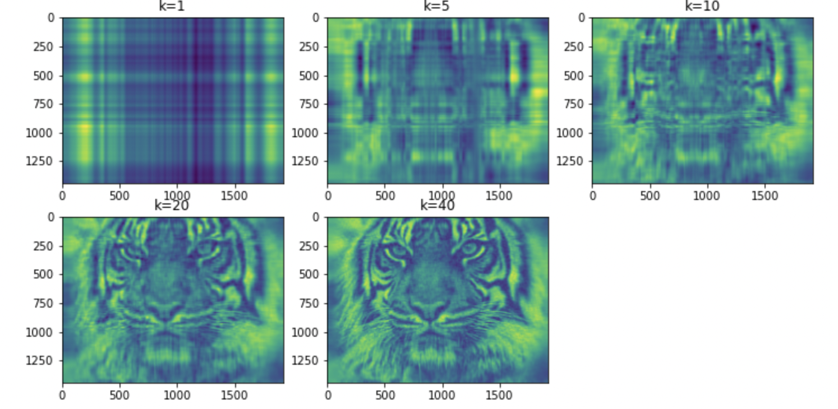

3. To run my Jupyter Notebook, download the given as a PNG file and save it under the same directory as the notebook with the name “image.png”. Then, just run the notebook and the result should be same as shown above.